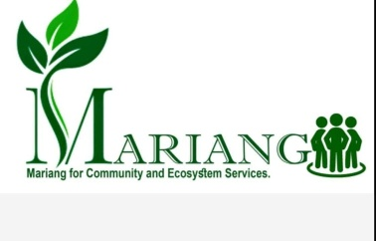

**Nurturing Nature and Community through Coffee Plantation (NNCCP)**

A Five-Year Integrated Farming Initiative by

**Mariang for Community and Ecosystem Services**

Year 1 – 2025 (July 1, 2025-June 2026)

## Background

The Khasi indigenous community in Bangladesh, stewards of nearly 10 million native trees through eco-friendly betel leaf cultivation, play a vital role in carbon sequestration, capturing approximately 2.5 million metric tons of CO₂ annually. These forests not only mitigate the negative impacts of climate change but also provide essential ecosystem services such as:

* Releasing oxygen and carbon sequestration
* Pollination
* Ensuring water table availability
* Providing food and shelter for animals and birds
* Protecting various small beneficial insects
* Safeguarding endangered flora and fauna

However, the community faces economic vulnerability due to its reliance on a single cash crop—betel leaf—making crop diversification crucial for sustainable development.

To address these challenges, the Khasi community has embraced coffee cultivation as a secondary cash crop. This innovative and integrated approach enhances their livelihoods while boosting forest health and increasing carbon sequestration. By integrating coffee farming into their practices, the Khasi community aim to strengthen their resilience against market fluctuations and environmental threats.

## What is it?

The Nurturing Nature and Community Through Coffee Plantation (NNCCP) is a five-year integrated farming initiative for the first time, providing resources and training to encourage the marginalized Khasi community in integrated farming by growing coffee alongside betel leaf. This will create a new source of income while protecting and enhancing the forest and biodiversity.

## What are we going to achieve?

Through this initiative, we are on the way to achieving the following:

**Economic Development:**

Promoting crop diversification through coffee cultivation, to enhance the livelihoods of the marginalized Khasi farmers. They will generate approximately $1 million additional income annually.

**Environmental Sustainability:**

Improving the local ecosystem through sustainable agricultural practices. Bangladesh is expected to sequester 4,800–7,000 metric tons of carbon annually in addition to 2.5 million metric tons from existing native trees, with plans to triple this impact in the next five years.

**Women Empowerment:**

The coffee cultivation project empowers Khasi women to take a leading role in agriculture and community development. Through participation in grower groups, they gain leadership skills, voice their opinions, and influence key family decisions. The project offers specialized training in group savings, financial literacy, family money management, nutrition, and maternal healthcare. By providing these skills and knowledge, the initiative boosts women’s financial independence, strengthens their community influence, and enhances their and their families’ quality of life.

**Job creation for youths:**

The Khasi community coffee initiative creates direct jobs for unemployed youth across coffee cultivation, processing, and marketing. It empowers young people to lead farmer groups, organize collective efforts, improve marketing, and ensure fair profit sharing. The program offers training in modern farming, processing, and business skills, helping youth build expertise and secure steady employment. By engaging youth in value-added activities like roasting and packaging, it fosters local skills development and inspires hope, steering them away from drug abuse and making them catalysts for positive community change.

**Enhancing Quality of Life:**

The Khasi community coffee initiative boosts overall well-being by increasing income that improves access to education, nutrition, and healthcare. Higher earnings from coffee farming and forest-friendly livelihoods enable families to secure clean water and better sanitation, positively impacting public health. The project promotes sustainable agriculture and forest restoration, preserving local culture, traditional knowledge, and dietary habits, thereby strengthening community identity. Active involvement in coffee production and forest management also supports conservation of forests, wildlife, and biodiversity in the Khasi Hills. Altogether, this initiative reduces poverty, fosters environmental sustainability, and enhances the community’s capacity to tackle social and ecological challenges.

## Current Progress

The project has already gained momentum even without external funding. The following progress made so far:

* We formed a community organization tilted, “Mariang for Community and Ecosystem Services”.
* The Soil Resource Development Institute confirms the region’s suitability for coffee cultivation.
* An MOU with North End Coffee Pvt. Ltd. ensures a guaranteed buyer for coffee beans.
* Local farmers received specialized training in November and December 2024.
* Mariang has organized three consultation meetings in April and May 2025 with two clusters of farmers and will complete all consultation meetings by June 31st.
* Five farmers established nurseries independently. 200,000 coffee saplings have started sprouting.
* On May 31st, Mariang, a community organization, signed a Memorandum of Understanding (MoU) with the Khasi Social Council, the platform representing Khasi village chiefs. Through this MoU, both parties committed to mutual support in advancing the socio-economic development initiative of the Khasi community like coffee plantation, preservation of the endangered culture and tradition, and in preserving forests, biodiversity, wildlife, watersheds, and other vital environmental resources.
* Many farmers showed a strong willingness to participate in coffee cultivation as a way to increase their income, provide their children with better educational opportunities, access improved healthcare, afford more nutritious food, and ultimately transition from being low GDP contributors to higher ones, while also helping to ensure a sustainable planet for future generations.

## CSR and Carbon Mitigation Alignment (For Private Sectors)

## Supporting the Khasi community’s coffee initiative, Mariang’s first major project, offers multifaceted benefits by empowering local farmers with sustainable income, improving education, healthcare, and nutrition, and elevating them from low GDP contributors to active economic participants. Private sector partners gain valuable national and international exposure for their branding and partnerships through various forums, enhancing their reputation while contributing to Corporate Social Responsibility (CSR) goals and carbon mitigation efforts by investing in carbon-sequestering coffee agroforestry. This initiative is critical to Mariang’s success, as its outcome will build the trust and confidence of key stakeholders essential for the socio-economic development of this marginalized community. By aligning with this project, companies not only foster environmental stewardship and social equity but also become pivotal supporters of a movement that promises sustainable growth and inclusive development on both local and global stages.

## Request for Funding Support

To reach these goals, we are requesting $300,000 in funding for year 1, 2025, through which we will provide the following:

* *200,000 coffee saplings to 3,000 farmers in 20 villages*
* *Training and consultation opportunities for approximately 9,000 farmers in 60 villages*
* *Formal group formation of farmers in 60 villages*
* *Fertilizer, bio-pesticides to farmers*
* *Constant advice and monitoring through full-time staff*
* *Publish and disseminate coffee training materials in the Khasi language*

## Join Us!

Supporting this initiative not only enhances local economic development but also contributes to global climate action goals. Your involvement will help the Khasi community protect their forests while improving access to education, nutrition, and healthcare services.

Join us in fostering equity, environmental sustainability, cultural preservation, and transforming a marginalized community—support the Khasi Coffee Plantation Initiative today! Please feel free to ask questions, make supportive suggestions or come and visit our various projects. We will take care of your accommodation and food.

To learn more or discuss further, please reach out to Antony Mukim, Executive Director, Mariang for Community and Ecosystem Services. Email: [abmukhim@gmail.com](mailto:abmukhim@gmail.com), Mobile: +8801755646463. Website: https://mariangbd.org/

**Images below showcasing the progress made to date:**

***Photo: Active participants in the coffee training at Magur Cherra Khasi village in Sreemangal***

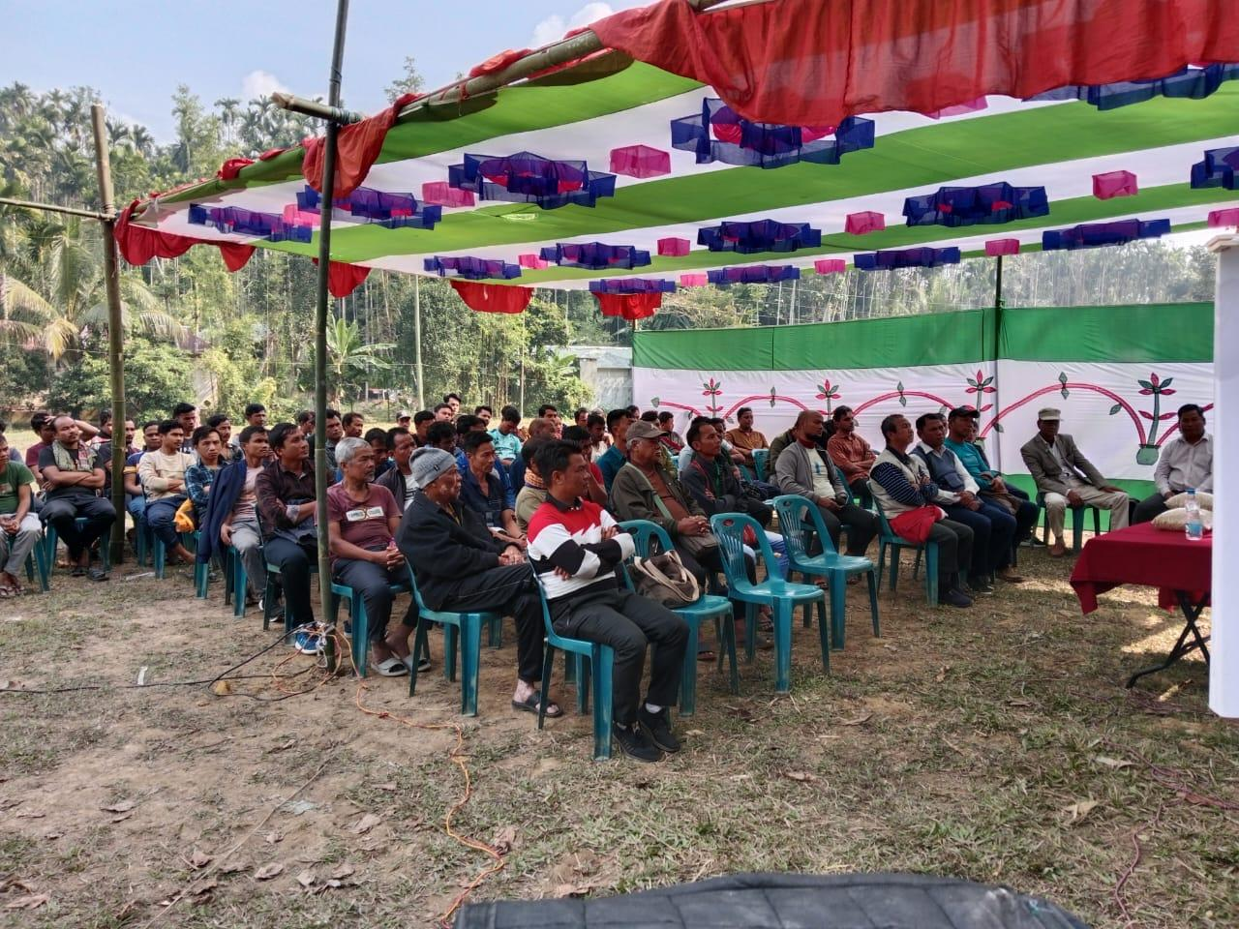

***Photo: Coffee sprouts in a nursery show new hope to the marginalized farmers***

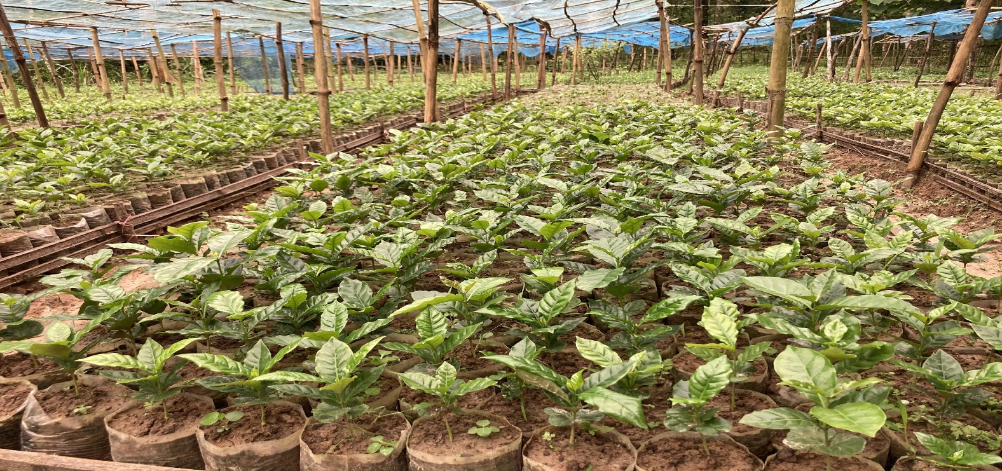

***Photo: A coffee tree of a Khasi farmer from Aliachora Khasi village in Bahubal sub-district***

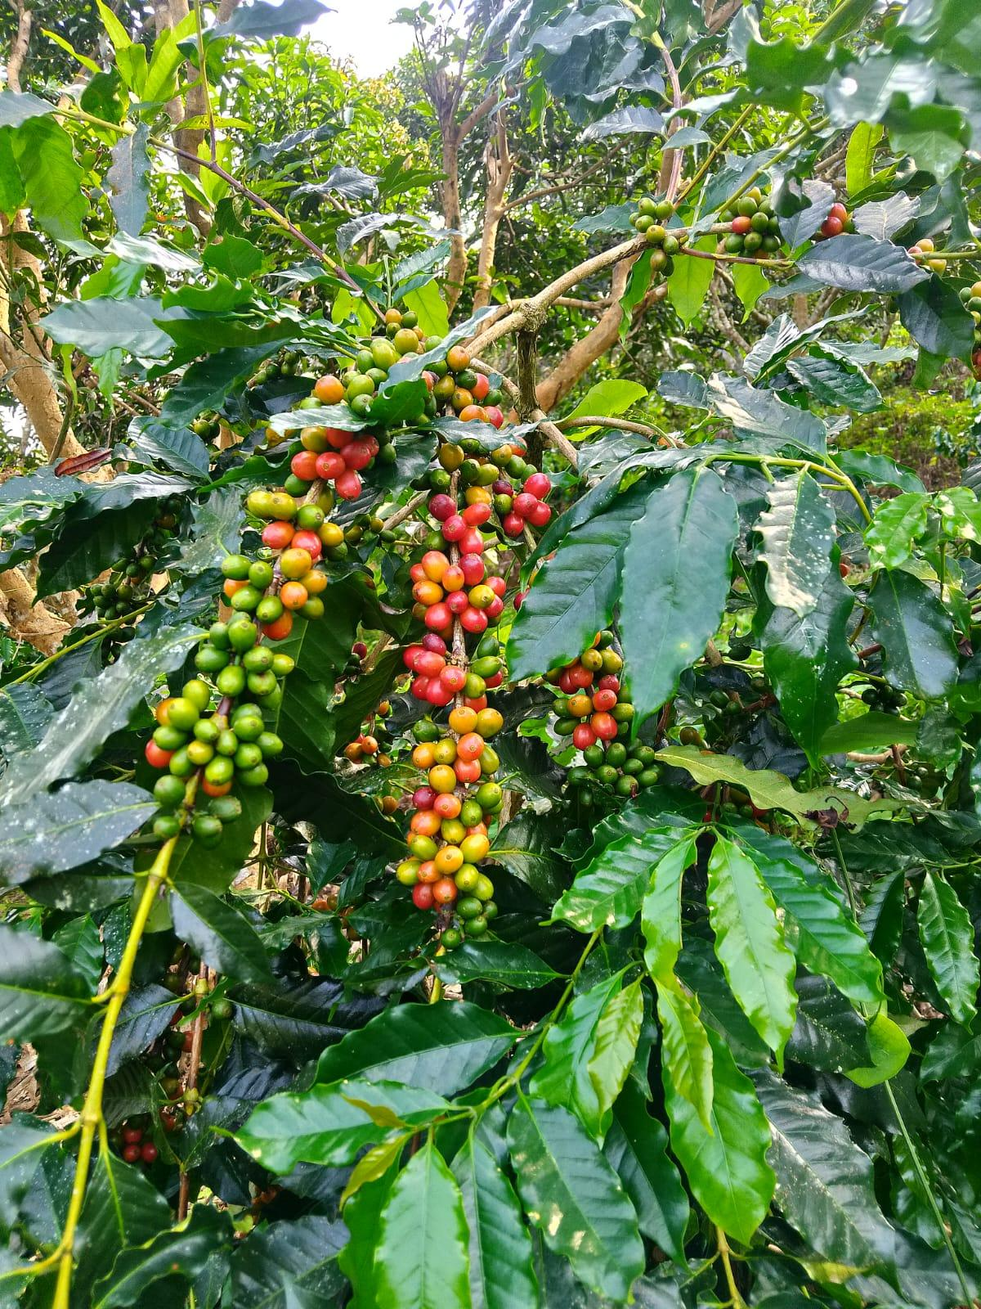

***Photo: A Khasi farmer from Klenji Khasi village in Sreemangal sub-district showing his self-roasted coffee to the North End Team***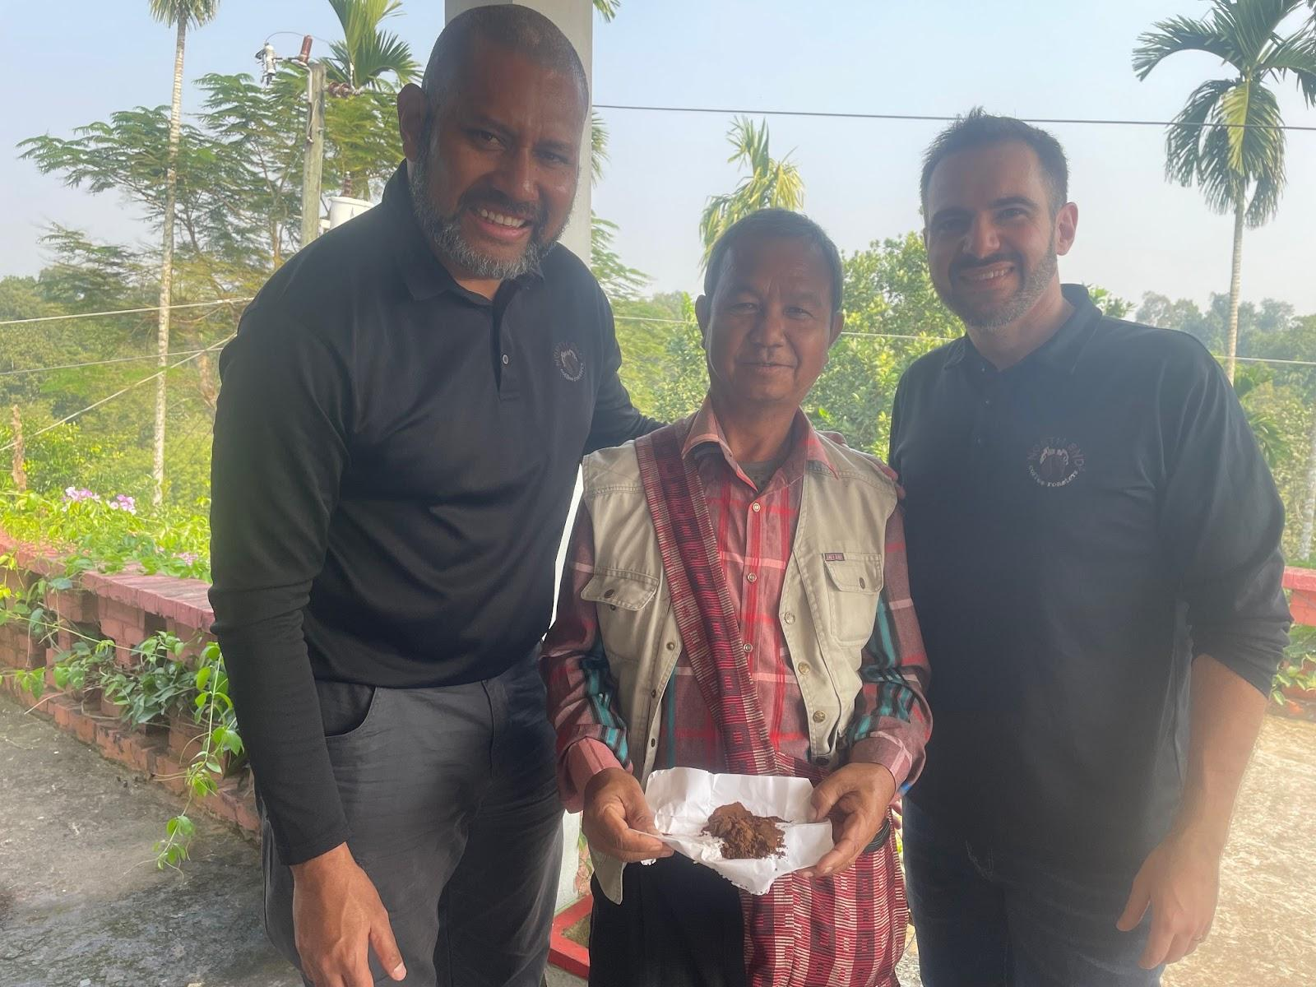

***Photo: A coffee tree of a Khasi farmer from 5 no. Khasi village of Borolekha sub-district***

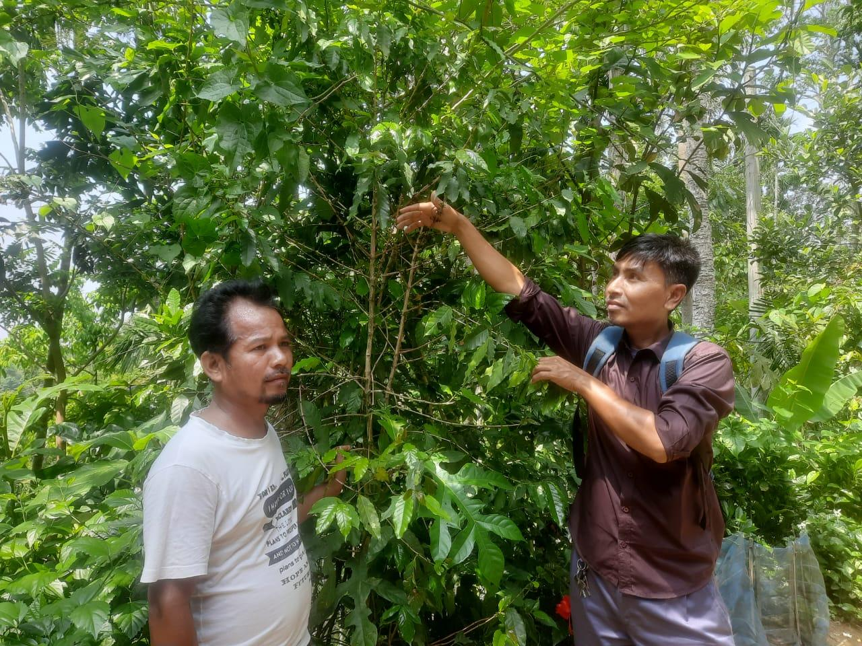

***Group Photo: Consultation meeting with the farmers at Brahmanbazar Mission, Kulaura Sub-district***

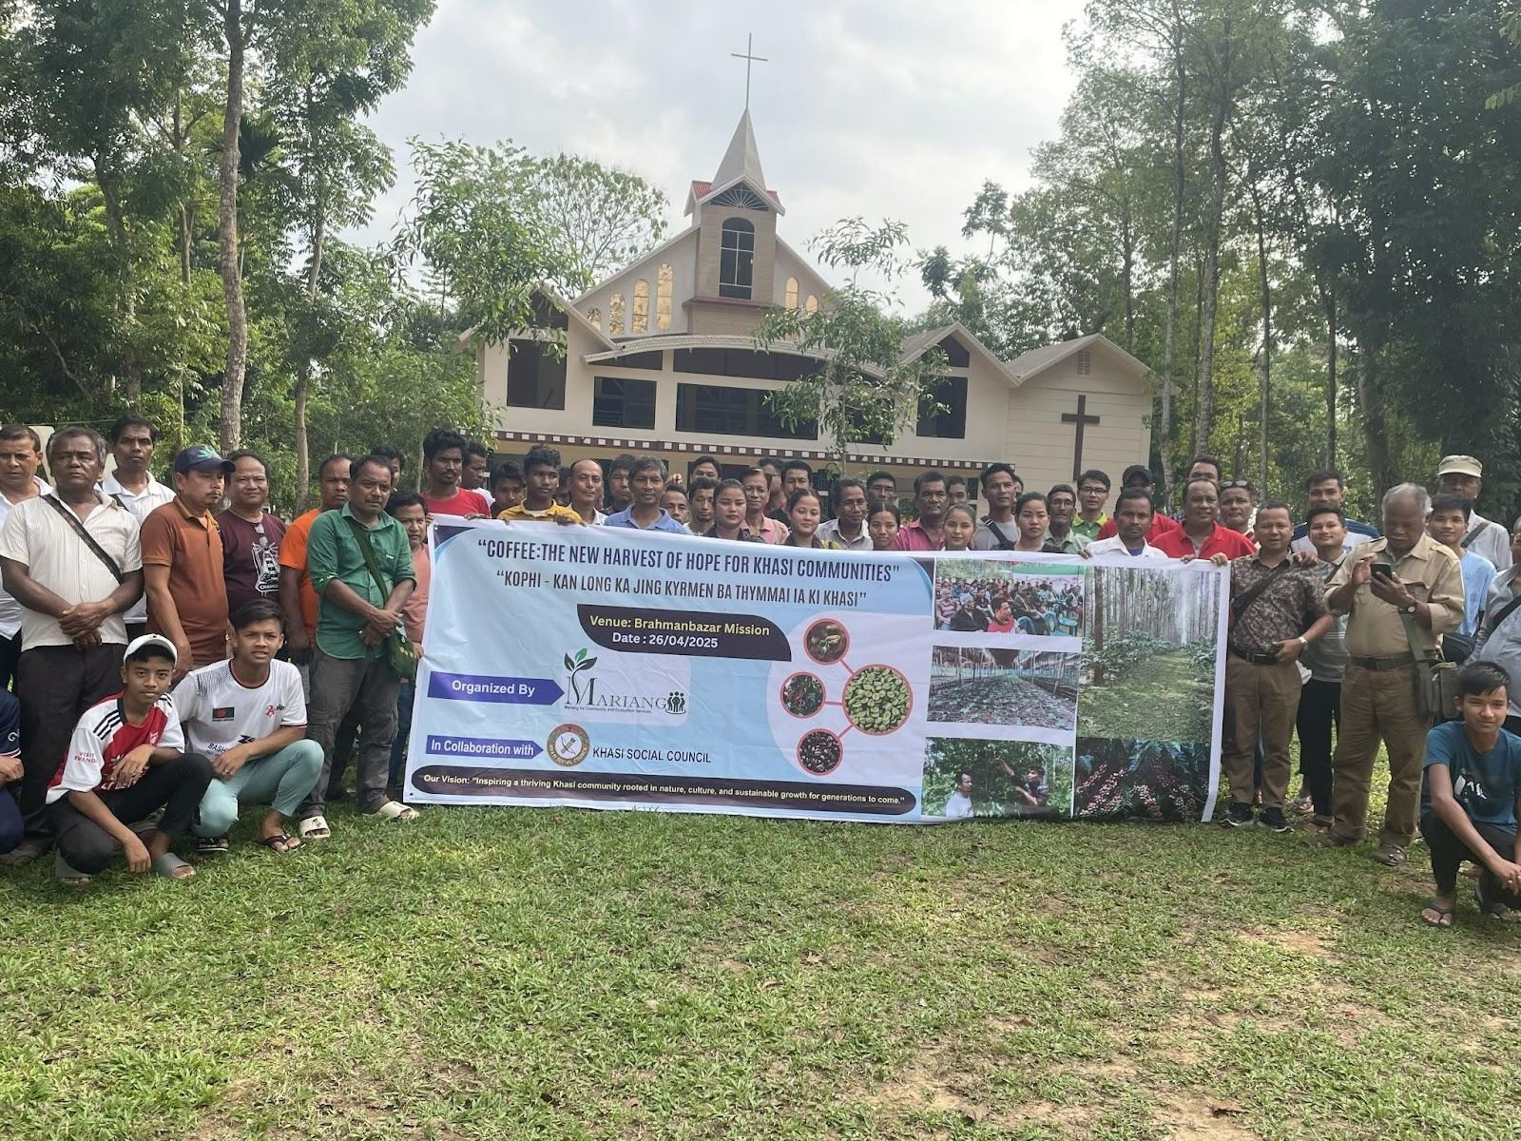

***Photo: Consultation meeting at Aliachora Khasi village, Bahubol sub-district***

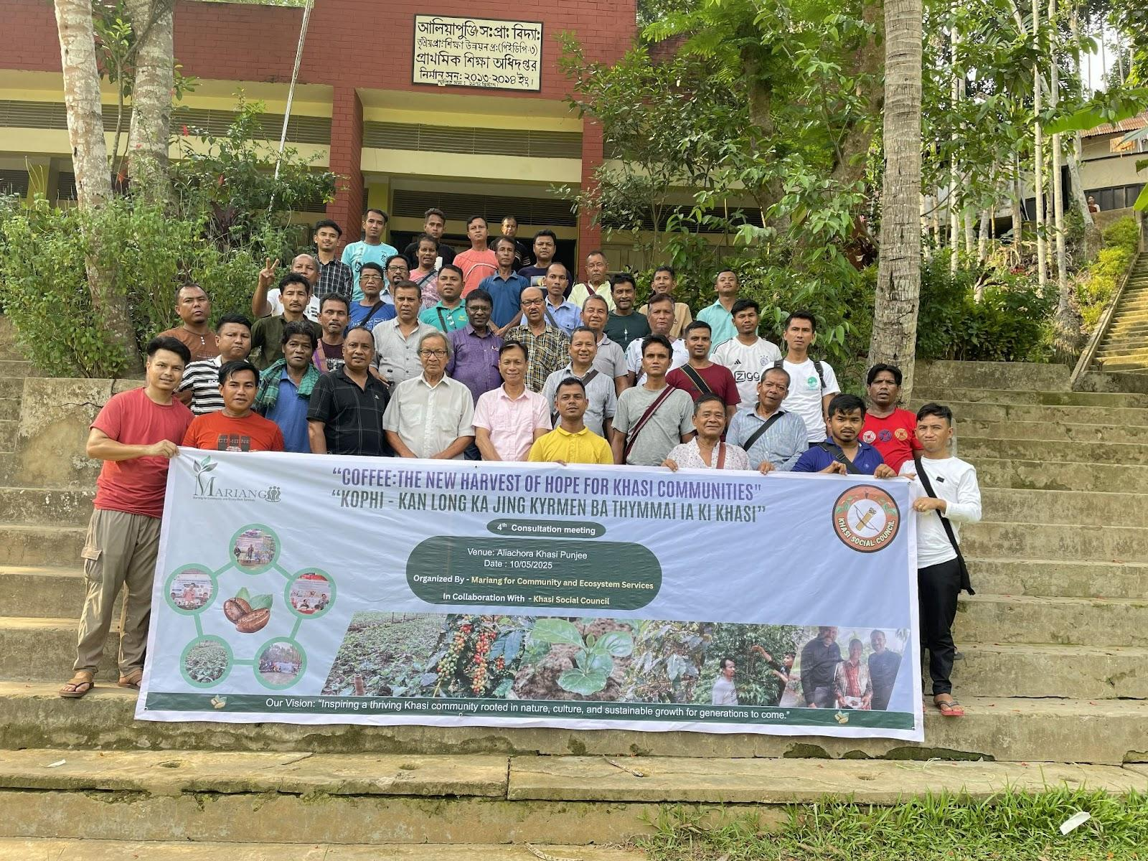

***MOU signed between Mariang, the community organization and Khasi Social Council, the platform of the village chiefs to support the community led development***

